Exhibiting at The Hive

Terms & Conditions

- The exhibitor is responsible for displaying their own artwork (set-up and breakdown), with direction by The Hive staff where appropriate. The Hive staff cannot provide assistance.

- There should be minimum disturbance to library and other services within The Hive when installing and exhibitors should make themselves familiar with the risk assessment.

- All paintings/pictures should be fitted with secure fixings; mirror plates are recommended. Please note: constant supervision is NOT provided. The Hive accepts no responsibility for damage or theft of items in the show unless caused by, or directly due to, the actions of our own staff. Insurance remains the exhibitor’s responsibility. Should a piece of artwork fall or become damaged, the exhibitor must repair this as soon as possible.

- The exhibitor is liable for any damage caused to The Hive's fixtures and fittings whilst installing or de-installing the exhibition. This includes residue left from improper products used to display pieces.

- Delivery and collection of all exhibits are the responsibility of the artist or group.

- Work must be exhibited only in the areas agreed by The Hive.

- The Hive reserves the right to reject any item thought to be unsuitable for exhibition. Arbitration of this issue shall be provided by the Programming Group at The Hive whose decision is final.

- The exhibitor is responsible for ensuring that all work to be displayed complies with UK legislation. Please pay particular attention to ensuring that copyright laws are not infringed.

- Publicity material is the responsibility of the exhibitor and The Hive will not be responsible for promoting the exhibition. However, exhibitors can provide descriptions and social media posts that can be shared on The Hive website and on The Hive social channels if appropriate.

- Private views can be accommodated following discussion with the events coordinator. A room booking will need to be made (bookings@thehiveworcester.org). Artists or the exhibiting organisation is responsible for any refreshments and invitations. Refreshments can be provided via The Hive; for more information, please contact hivecatering@bellrock.fm

- Labelling work and compiling a catalogue is the exhibitor’s responsibility.

- Sales are to be handled by the artist.

Costs
(Prices are per week)
Atrium, Level 1*  (including use of up to 40 exhibition panels offering up to 80 sides to display) | £50
Café Wall, Level 1*  (up to 7 pieces, max load 15kg each) | £25
Display Cabinet, Café Level 1 (up to 3 cabinets) | £15 per cabinet
Display Cabinet, Atrium Level 1 (up to 3 cabinets) | £15 per cabinet

- All booking fees are non-returnable. Fees are invoices after your exhibition has finished and details of how to pay will be included.

- Signed acceptance forms must be returned within the stated time period. Failure to do so may mean offers of exhibitions are withdrawn and reallocated.

*Please note that the Atrium exhibition panels and Café Wall are fitted with hanging systems and are ideal for displaying framed pieces. If you wish to show mounted prints or other such lightweight items, then specialist fixings must be purchased at a cost to the artist.

Useful Information

Display Boards

- There are 40 exhibition panels in total with the configuration options of 8 ‘T’ joints, 6 ‘L’ joins and 5 ‘X’ joints to form different shapes.

- Each board is H2000mm x W900mm.

- There are approximately 200 hanging sets available to use. The number of pictures that the hanging sets will accommodate will vary on size, shape and weight of the work you wish to exhibit.

- Smaller and lighter items can be hung using an alternative damage free hanging solution such Command Strips - which will need to be purchased by the exhibitor.

- Exhibitors can request the boards to be configured how they wish, and this can be a combination of shapes. However, to maximise the safety of the boards, shape configurations are set to:
X shape – 4, 8, or 12 boards
T shape – 3 or 5 boards
L shape – 2,4 or 6 boards

Set-up and Breakdown Guidance

- The best time to set-up is on a weekday, preferably between 2-3pm, when there is a maximum number of caretaking staff on duty.
- Breakdown is usually at a weekend and exhibition areas will need to be cleared by Sunday at 6pm.
- Exhibitors are responsible for safety setting up and taking down exhibitions. The Hive cannot provide assistance.
- Exhibitors can gain access to the building either through the main entrance or through the Hive loading bay.
- Arrival dates and times will need to be confirmed prior to exhibition set-up so that front of house staff, caretakers and security staff can be informed.
- For easy access, exhibitors can drive up to the bollards just off Cattle Market car park. Press the intercom and either the Caretaker or Security will answer, just let them know you are here for an exhibition and they will then lower the bollards to allow you to drive up to either unload next to the ramp or drive further up to access the loading bay – this is opposite arch number 31. If you require any assistance call 01905 542 002 and ask for Caretaker when prompted. The best access to the building is through our main entrance which takes you straight into the Atrium. This is more suitable for larger pieces of work.
- The loading bay has a raising platform that can deliver items to the Atrium. However, this may not be suitable for larger items as the corridor access has 90-degree corners. Please speak to the events coordinator if you have larger items.
- You can request items of furniture to be set up as part of your exhibition, these include tables, chairs and sofas. Please speak to the events coordinator if you would like to include these. We recommend that these are only used if your exhibition layout has plenty of empty space to allow access for pushchairs and wheelchair users.
- The Hive will provide all exhibitors with a copy of the generic risk assessment for exhibitions which we request that exhibitors read prior to arrival. We strongly recommend that you also write your own risk assessment, particularly if you intend to use power tools or work at height. The Hive will need to see a copy of this for review before your exhibition date.

Exhibition Lay out examples:

Orange – Display Boards
Blue – indicates exhibition space (not boards)

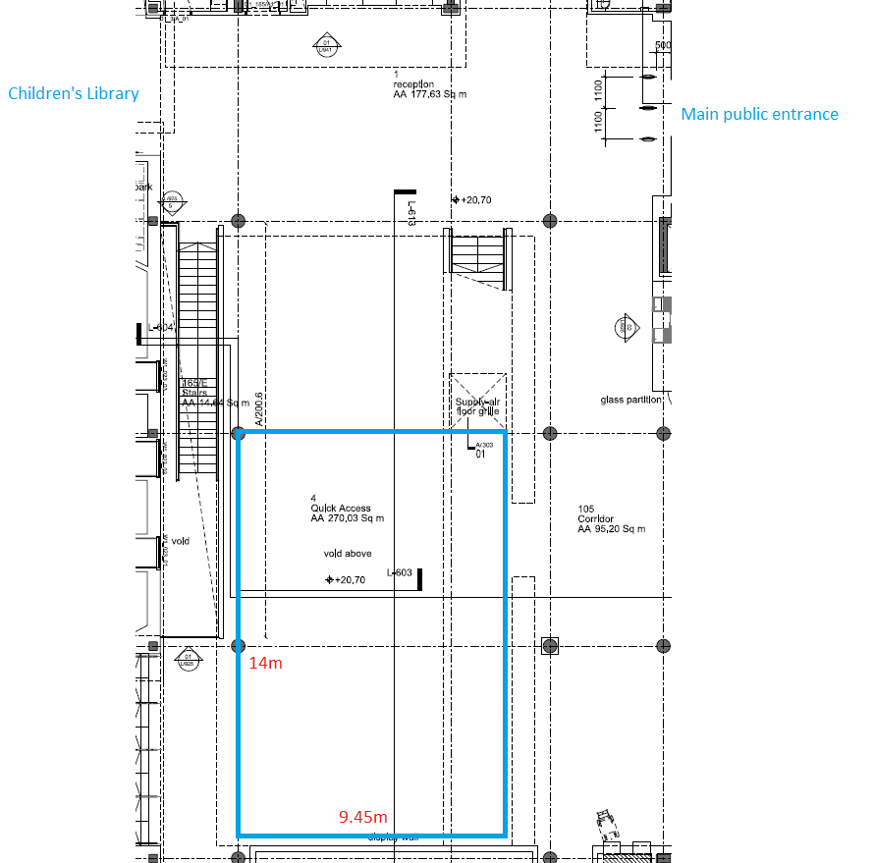

Hanging System:

Clear wires are suspended from hooks secured at the top of the display boards. These typically have two fastenings on each wire that can be moved up and down depending on the size and configuration of the artwork. Pictures are then secured onto the fastenings by hooking the wire/string at the back of the artwork onto the fastenings and tightening the fixing into place.

Alternatively, you may want to use Command Strips to secure your artwork as details in the terms and conditions above.

